Checkpoint

**Description**

* Save player progress
  + Respawn point
* Visual component to show it is active

The checkpoint system allows the player to save character progress through the level by changing the player’s respawn point. By passing a checkpoint, it will activate and from then until a further checkpoint is activated, when the player dies, they will respawn at the checkpoint.

The checkpoint has two states, active and inactive. As stated earlier, when the player walks past the checkpoint, it will activate and switch states. When changing from one state to the other, the checkpoint will visibly alter to show that it has changed states.

The checkpoint design is based on a standing torch. It has four wooden poles as the base of the torch that intersect near the top of the torch, before spreading back out at the top. The top section holds a metal container that will be the part that gets set alight while the checkpoint is active.

**User Story**

As a player, I want to have my level progress retained on death so that I don’t have to re-do certain sections

As a player, I want checkpoints to show that it is activated so that I know my progress is saved

**Validation**

Scenario: Player comes across a checkpoint

Given I’m a player, when I walk across a checkpoint, the checkpoint becomes active and when this happens, the checkpoint visibly changes showing that it is activated

**Design Diagram**

Before Checkpoint Activation

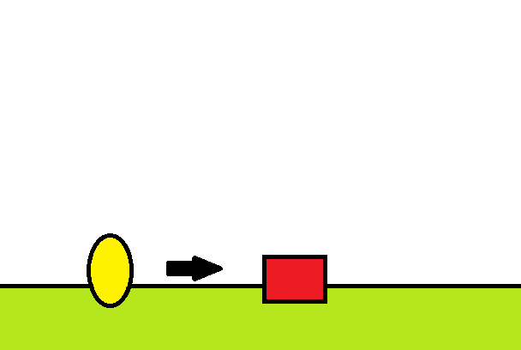

Player

Inactive Checkpoint

Move Direction

After Checkpoint Activation

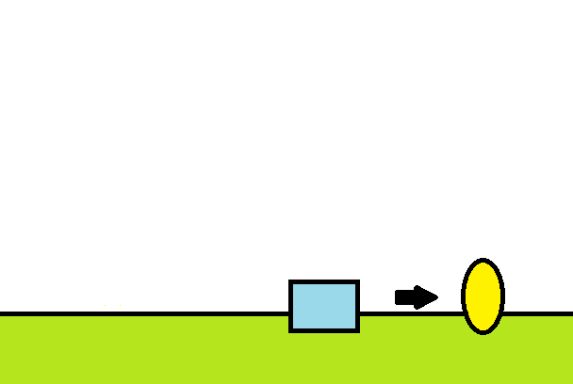

Active Checkpoint

Reference

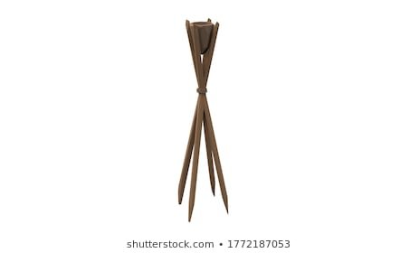

Poor Representation

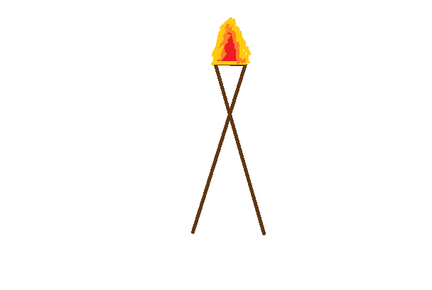

4 legs to prop the object up

Small container that holds the flammable bits

Fire activates when checkpoint is active